Satari Ahmad Tahir – 4508210070 Teknik Informatika
Catatan Pemrograman 3

Flow Layout

Coding untuk Flow Layout

package com.artivisi.project;

import javax.swing.*;
import java.awt.FlowLayout;

public class DemoFlowLayout {
public static void main(String[] xx){
// Beberapa button untuk demo
JButton btn1 = new JButton("Tombol 1");
JButton btn2 = new JButton("#2");
JButton btn3 = new JButton("Tombol Tiga");
JButton btn4 = new JButton("Tombol 4 : Panjang");
JButton btn5 = new JButton("Btn 5");
JButton btn6 = new JButton("No. 6");

JPanel panel = new JPanel();
panel.setLayout(new FlowLayout());
panel.add(btn1);
panel.add(btn2);
panel.add(btn3);
panel.add(btn4);
panel.add(btn5);
panel.add(btn6);

// menginstankan Frame
JFrame fr = new JFrame("Belajar Layout");

fr.getContentPane().add(panel);
// ukuran frame
fr.setSize(800,200);

// posisi di tengah
fr.setLocationRelativeTo(null);

// tampilkan
fr.setVisible(true);
}
}

Dan dicomplie menggunakan command

D:\Pemrograman3\my-app>mvn clean package exec:java -Dexec.mainClass=com.artivisi
.project.DemoFlowLayout

Akan menghasilkan
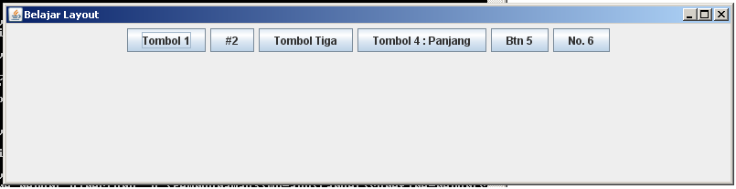

Coding untuk Grid Layout

package com.artivisi.project;

import javax.swing.*;
import java.awt.GridLayout;

public class DemoGridLayout {
public static void main(String[] xx){
// Beberapa button untuk demo
JButton btn1 = new JButton("Tombol 1");
JButton btn2 = new JButton("#2");
JButton btn3 = new JButton("Tombol Tiga");
JButton btn4 = new JButton("Tombol 4 : Panjang");
JButton btn5 = new JButton("Btn 5");
JButton btn6 = new JButton("No. 6");

JPanel panel = new JPanel();
panel.setLayout(new GridLayout(3,2));
panel.add(btn1);
panel.add(btn2);
panel.add(btn3);
panel.add(btn4);
panel.add(btn5);
panel.add(btn6);

// menginstankan Frame
JFrame fr = new JFrame("Belajar Layout");

fr.getContentPane().add(panel);
// ukuran frame
fr.setSize(800,400);

// posisi di tengah
fr.setLocationRelativeTo(null);

// tampilkan
fr.setVisible(true);
}
}

Dan dicomplie menggunakan command

D:\Pemrograman3\my-app>mvn clean package exec:java -Dexec.mainClass=com.artivisi
.project.DemoGridLayout

Akan menghasilkan
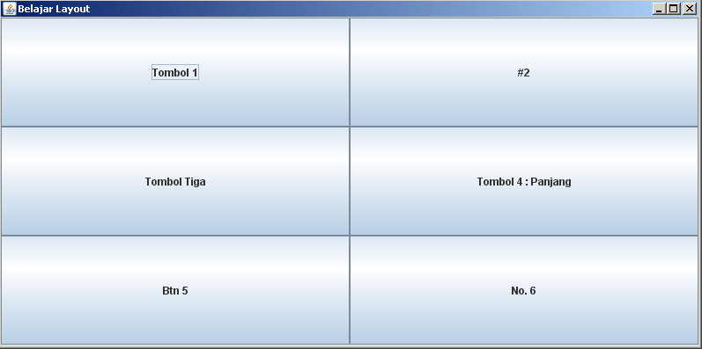

Coding untuk Border Layout

package com.artivisi.project;

import javax.swing.*;
import java.awt.BorderLayout;

public class DemoBorderLayout {
public static void main(String[] xx){
// Beberapa button untuk demo
JButton btn1 = new JButton("Tombol 1");
JButton btn2 = new JButton("#2");
JButton btn3 = new JButton("Tombol Tiga");
JButton btn4 = new JButton("Tombol 4 : Panjang");
JButton btn5 = new JButton("Btn 5");
JButton btn6 = new JButton("No. 6");

JPanel panel = new JPanel();
panel.setLayout(new BorderLayout());
panel.add(btn1, BorderLayout.NORTH);
panel.add(btn2, BorderLayout.SOUTH);
panel.add(btn3, BorderLayout.WEST);
panel.add(btn4, BorderLayout.EAST);
panel.add(btn5, BorderLayout.CENTER);

// tidak bisa add button 6, tempatnya cuma 5
// panel.add(btn6);

// menginstankan Frame
JFrame fr = new JFrame("Belajar Layout");

fr.getContentPane().add(panel);
// ukuran frame
fr.setSize(800,400);

// posisi di tengah
fr.setLocationRelativeTo(null);

// tampilkan
fr.setVisible(true);
}
}

Dan dicomplie menggunakan command

D:\Pemrograman3\my-app>mvn clean package exec:java -Dexec.mainClass=com.artivisi
.project.DemoBoerderLayout

Akan menghasilkan
